Legal & General Assurance Society Limited
PO Box 5458, City Park, The Droveway, Hove, BN52 9GL
Contract number(s):
<Insert the number shown on your letter>
Contract name:
< Insert the name shown on your letter>
Policy Transfer Helpline:
0800 048 1026 (UK-Freephone) or
+44 1273 374130 (International calls)
Open Monday to Friday, 9am to 5pm
For international calls, call charges will vary
We will record and monitor calls
Email address: scheme.response@landg.com
Be aware that email isn’t a secure method of communication

<Month_2019>

Private and Confidential

<Member_Full_Name>
<Full_Address_Line_1>
<Full_Address_Line_2>
<Full_Address_Line_3>
<Full_Address_Line_4>
<Full_Address_Line_5>
<Full_Postcode>

Important News – We’re proposing to transfer the
policy supporting your membership of the pension
scheme to another provider
<Insert the pension scheme name shown on your letter>
Dear <Member name>
What’s happening?
Legal & General is proposing to transfer its traditional insurance-based savings, pensions, life and with profits business to ReAssure Limited (ReAssure). This includes your contract name shown above which supports your membership of the pension scheme. Please read this information pack carefully so you understand what is happening and what it means for you and the pension scheme.
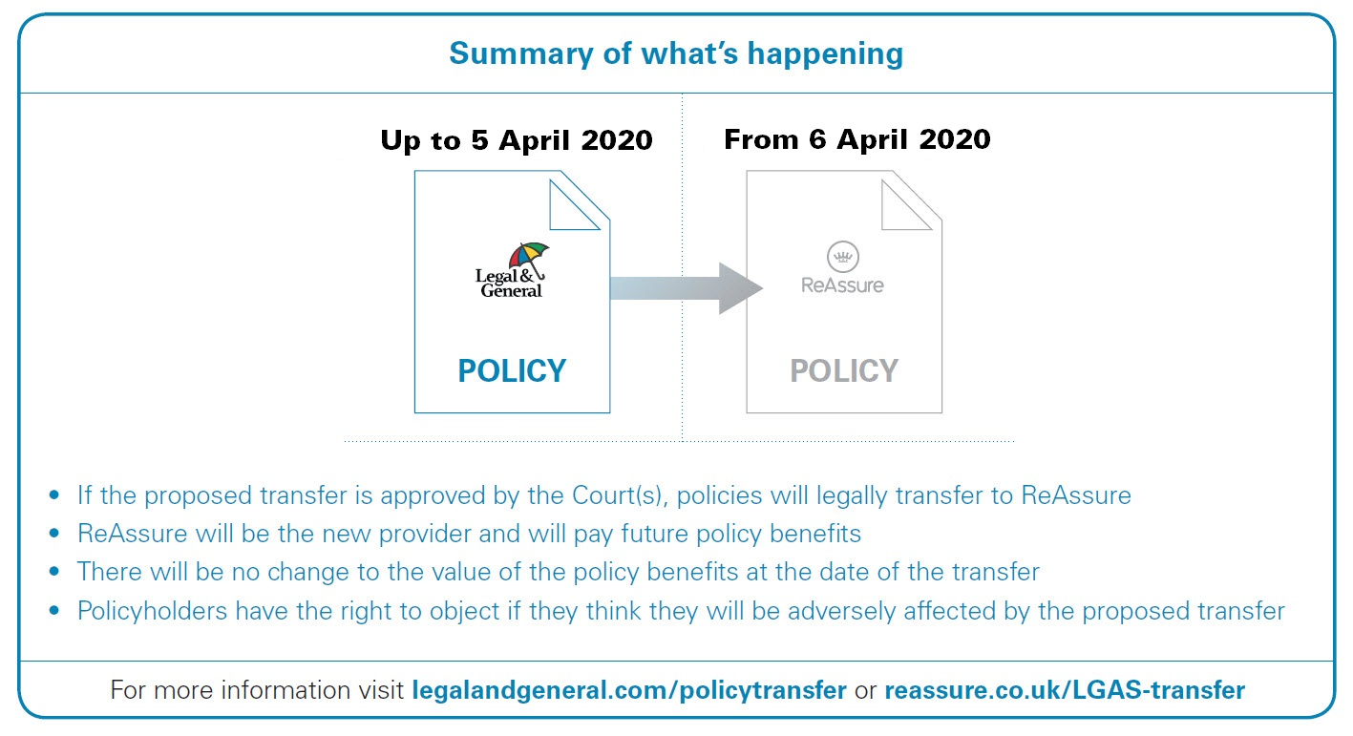
PENSION SCHEME MEMBER LETTER TEMPLATE (JAN 2020)
Why is Legal & General doing this?
Since 2015, Legal & General’s traditional insurance-based savings, pensions, life and with profits policies have been largely closed to new customers. At the same time, we’ve shifted our focus to growing our business in other areas, such as creating new annuity and insurance contracts; and offering well designed, good quality investment options for our growing workplace savings community.

After a considered process, Legal & General has chosen ReAssure to take this business forward as ReAssure’s core business is acquiring and administering closed portfolios of insurance business. ReAssure is therefore experienced in managing this type of business and well-suited to take over from Legal & General.

ReAssure has over 2.2 million customers and looks after investments of over £39 billion on behalf of its customers. ReAssure employs over 2,000 staff in locations across the UK. You can find out more about ReAssure and its history by visiting reassure.co.uk/about-us

How will the proposed transfer affect you?
The transfer of the pension policy to ReAssure is designed to have a minimal impact on you. The Trustee of the pension scheme and the scheme administrator will remain the same. The value of the pension policy at the date of transfer will not be affected by the transfer. Neither will the contract number(s).

During and shortly after the transfer, there may be a short period when service levels may be impacted. This is because of the activities required to enable a smooth transfer to ReAssure. Service levels will be back to normal soon after the transfer date.

We would like to draw your attention to the main changes to be made as a result of the proposed transfer, which are described in more detail in PART A3 of the enclosed Scheme Guide. The key points relating to the proposal are:

- If the proposed transfer is approved, the pension policy is expected to transfer to ReAssure on 6 April 2020. ReAssure will be the provider of the pension policy from then.
- If the contract is invested in the With Profits Fund, there will be specific changes to the way it is managed in the future. More details of the proposed changes can be found in PART C1 and a Summary of the Independent Expert’s Report in PART E of the enclosed Scheme Guide.
- If the contract is invested in a unit linked fund(s), there will be specific changes to the way your fund(s) is managed. In summary, these include: a minor change to the name of your fund(s); a change to the timing of when fund charges are taken (but there is no change to the rate of your fund charge); and a change to the time that your fund(s) is valued each day. More details of the proposed changes can be found in PART C2 and a Summary of the Independent Expert’s Report in PART E of the enclosed Scheme Guide.
- After the proposed transfer has taken place you’ll no longer be able to view details about the pension scheme on the Legal & General website or the online account management facility, if applicable. If the transfer is approved, eligible customers will be able to register for the ReAssure portal, called ‘ReAssure Now’. ReAssure will use a phased launch to introduce this service to customers.
In order for ReAssure to be able to communicate with you, manage any payments under the pension policy and take any other appropriate actions required under the pension policy, Legal & General needs to transfer the pension policy information and your personal data to ReAssure. Legal & General and ReAssure will ensure the transfer is in accordance with the requirements of the relevant data protection legislation. This includes ensuring personal data is kept appropriately secure. More information about this transfer can be found in PART B1.18 of the enclosed Scheme Guide.

How will the proposed transfer take effect?
The proposed transfer will be carried out as an insurance business transfer scheme (the Scheme) under the Financial Services and Markets Act 2000. This requires us to obtain approval of the Scheme from the High Court of Justice of England and Wales (the High Court). The hearing of the High Court to consider whether to approve the proposed transfer is due to commence on 9 March 2020 at the High Court, 7 Rolls Buildings, Fetter Lane, London EC4A 1NL. A Summary of the Terms of the Scheme can be found in PART D of the enclosed Scheme Guide and more information about the process can be found in PART A2.

Where the Trustees of the pension scheme are residents of Guernsey, and in respect of business carried on in or from within Jersey, the proposed transfer will be carried out in accordance with the equivalent Jersey and Guernsey law and will require approval from the local courts in Jersey and Guernsey respectively (together with the High Court, described as the Courts). More information about this process can be found in PART G of the enclosed Scheme Guide.

Subject to approval by the Courts, it is expected that the pension policy will transfer to ReAssure on 6 April 2020. Under the current Scheme, Legal & General and ReAssure can agree to defer the transfer up to 6 July 2020 without further approval from the Courts. Any change to the date of the transfer will be published on legalandgeneral.com/policytransfer

How are your interests being protected?
The court approval process for the transfer to ReAssure protects policyholders in a number of ways to make sure they are not adversely affected. The protections include:

- This advanced notification that is intended to provide you with information about the proposed transfer, allowing reasonable time for you to consider whether you believe you may be adversely affected. If you think you may be adversely affected by the proposals, then you have the right to raise an objection with the appropriate Court. More information on how to object is set out below.
- The appointment of an Independent Expert, with the approval of the Prudential Regulation Authority (after consultation with the Financial Conduct Authority), to write a report on the effect of the proposed transfer on policyholders. A Summary of the Independent Expert’s Report can be found in PART E of the enclosed Scheme Guide. The Independent Expert concludes “I am satisfied that the transfer would not have a material adverse effect on: the security of the benefits of the policies of Legal & General and ReAssure; the reasonable expectations of the policyholders of Legal & General and ReAssure in respect of their benefits; or the standards of administration, service, management and governance that apply to the Legal & General and ReAssure policies. I am also satisfied that the transfer is equitable to all classes and generations of Legal & General and ReAssure policyholders.”
- The relevant Court must approve the transfer for it to go ahead. The relevant Court will consider the views of policyholders and other interested parties, the Independent Expert and the Financial Conduct Authority and Prudential Regulation Authority (the Regulators) before reaching a decision on whether to approve the proposed transfer.
- Finally, the Regulators, whose roles are to protect customers amongst other things, have each reviewed and been given the opportunity to comment on the proposed transfer.
What should you do now?
We recommend that you read the enclosed Scheme Guide which contains more detail about the proposed transfer, so you understand what is happening, and how your membership of the pension scheme may be affected.

Throughout the Scheme Guide, you will notice words that are in bold text. We explain these words at the front in the part entitled “Definitions”. We’ve also divided the Scheme Guide into parts to make it easier to follow and those parts that currently apply to you and the pension policy are listed below:
PART A: Answers to general questions.
PART B: Information for policyholders & interested parties.

PART C1: If the contract is invested in the With Profits Fund, specific changes to the way the policy is managed.

PART C2: If the contract is invested in a unit linked fund(s), specific changes to the management of the fund(s).

PARTS D, E & F: Further information for all policyholders.
If you are satisfied with the proposals, you don’t need to do anything.

If you think you may be adversely affected by the proposals, then you have the right to object to or raise your concerns and an objection with the appropriate Court. You or a representative of yours has the right to attend the hearing at the relevant Court to present any objections or concerns that you may have in person. Alternatively, you can telephone or write to us rather than appear in person. We will pass any objections we receive from you to the Regulators, the Independent Expert and to the relevant Court for consideration.
Full details of how to object to the proposed transfer, or raise your concerns and an objection with the appropriate Court are included in PART A4 of the enclosed Scheme Guide.

Where else can you find information about the proposed transfer?
Should you need any further information about the proposed transfer, or if you have any questions or concerns about the proposed transfer or consider that you may be adversely affected by it, you can:

- Call us on our Policy Transfer Helpline 0800 048 1026 (UK-Freephone) or +44 1273 374130 (International calls),
- Write to us or email us at: Policy Transfer Team, Legal & General, PO Box No. 5458, City Park, The Droveway, Hove, East Sussex, BN52 9GL or scheme.response@landg.com
- Alternatively, write to Legal & General’s solicitors at: Slaughter and May, One Bunhill Row, London EC1Y 8YY (Ref: RAC/MXC).
If you intend to contact us in any of the above ways, you can do so up until the sanction hearing which is due to commence on 9 March 2020. We would ask that you contact us using the details above as soon as possible so that we can make a note of your questions or concerns, reply to you and share these with ReAssure, the Courts, the Independent Expert and the Regulators before the sanction hearing. Please also let us know if you or a representative, decide to attend the hearing so that we can make sure you are kept up-to-date with accurate timings, venue and any other arrangements.
Please note that these contact details are for questions about the proposed transfer to ReAssure only. If you have any questions other than about the proposed transfer, please contact the customer services team in the usual way (shown on any previous correspondence).
When calling or writing to us, we will be able to deal with your enquiry more quickly if you provide your full name, contract name and contract number and the reference details noted on the front page of this letter.
This information pack, additional documents and information on how to object to the proposed transfer are available on the Legal & General and ReAssure websites at legalandgeneral.com/policytransfer and reassure.co.uk/LGAS-transfer All updates and details about the progress of the transfer, including any supplemental reports that may be prepared prior to the hearings at the Courts, will also be posted on these websites and will be available from the same address above.
And, finally…
If you are a member of more than one pension scheme transferring to ReAssure, you may receive more than one letter like this. Please read all the letters you receive carefully as you may be affected differently depending on the contract you hold.

If you are aware of anyone else who has an interest in and/or who is entitled to benefits under the contract number(s) shown in this letter (such as any nominated beneficiary, executor or personal representative) please inform them of our proposals and pass on the information contained in this letter and the enclosed Scheme Guide. Details of what you should do in such circumstances are included in PART A5 of the enclosed Scheme Guide.

Importantly, news of Legal & General’s proposed transfer to ReAssure is in the public domain, so please be aware of any scam calls, letters or emails from fraudsters that may offer you fake advice about what you should do with your pension scheme benefits. Information that will help you identify scams and how to avoid them is available at moneyadviceservice.org.uk

If you would like a copy of this pack in braille, audio or large print, please contact our Policy Transfer Helpline on 0800 048 1026 (UK-Freephone) or +44 1273 374130 if you are calling from overseas.

Yours sincerely,
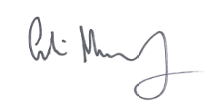
Colin Murphy
Chief Executive Officer, Mature Savings Division

For details on how we use your personal information, please read our privacy policy. Our most recent version is on legalandgeneral.com/existing-customers/privacy

